SESSION 7 ASSIGNMENT 2

Problem Statement

1. Write a Hive program to find the number of medals won by each country in swimming.

-- SUM FUNCTION TO SUMUP TOTAL MEDAL IN SWIMMING ,COUNTRY WISE.

SELECT country, sum(total_medal) from Olympic

where sport = 'Swimming'

group by country;

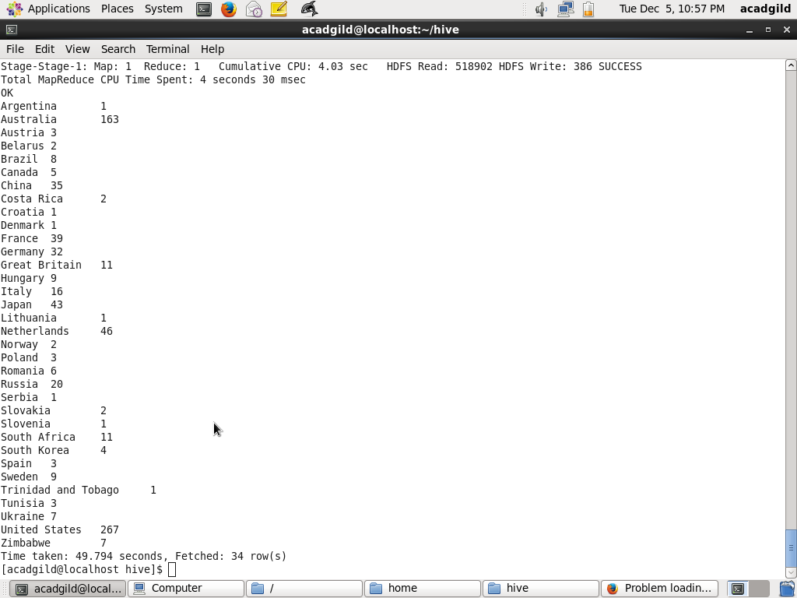

2. Write a Hive program to find the number of medals that India won year wise.

SELECT country, year,sum(total_medal)

from olympic

where country = 'India'

group by country,year

order by year;

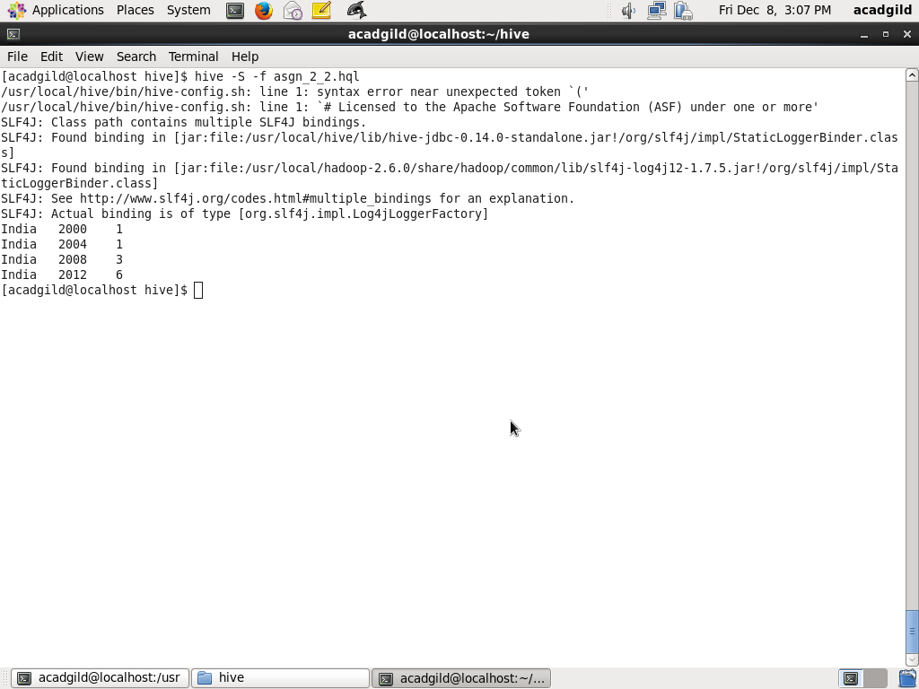

3. Write a Hive Program to find the total number of medals each country won.

SELECT country, SUM(total_medal)

FROM olympic

GROUP BY country;

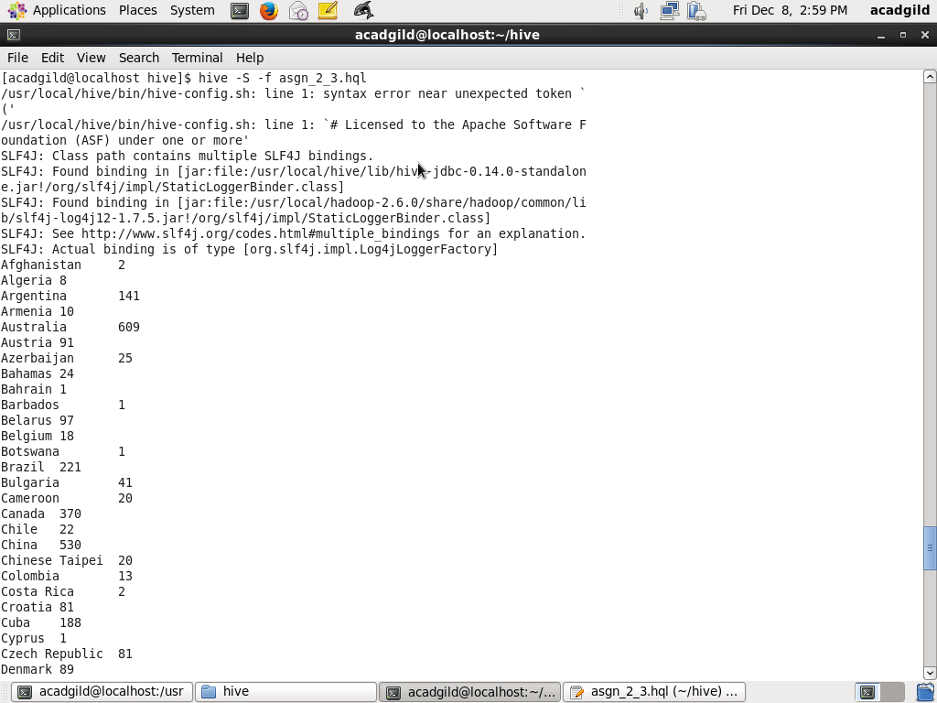

4. Write a Hive program to find the number of gold medals each country won.

select country, sum(gold_medal)

from olympic

group by country;

